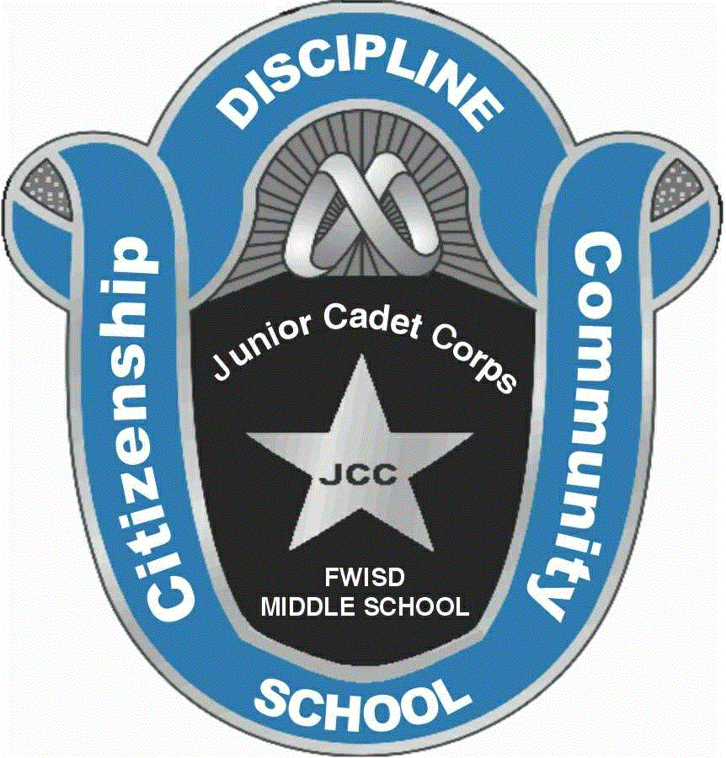
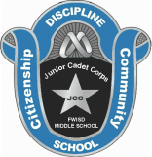

From: JCC Instructor
To: Parents/Guardians

Subject: COURSE SYLLABUS

Course Information/Text:
First and Second Semester JCC Students Course number – 0166A/0176A
Designated Grade Level: 6, 7, 8
Prerequisite: None

Texts:
Junior Cadet Corps Cadet Handbook and Text Books (JCC 1 and JCC 2)

Goals:
- Develop leadership and build character.
- Create informed, patriotic, and responsible citizens.
- Develop responsible young adults who are physically, mentally, and morally fit.
- Develop informed and civic-minded young adults prepared for higher education, civilian careers, and public service.
- Instill structure, respect, and responsibility through challenging activities
Learning Objectives:

During the course of the school year, the student will have the opportunity to learn the following knowledge and skill objectives.

- Individual rights, responsibilities, privileges, and freedoms that underline good citizenship for constituted authority.
- Leadership potential and the ability to live and work cooperatively with orders.
- The ability to think logically and to effectively communicate orally and in writing.
- The importance of a well balanced diet and physical training in maintaining good health.
- An understanding of the history, purpose, and structure of JROTC.
- Basic military skills, such as drill and ceremony, first aid, and map reading.
- Citizenship, as it pertains to American culture and its future.
- Knowledge of the dangers of substance abuse.
- The importance of goal setting and positive thinking.
- Personal traits
- Teamwork and group dynamics.
- Community services.

Uniforms:

Each student will be required to wear a complete cadet uniform at the cost to the student. All Cadets are required to have their uniforms no later than October 3, 2014. Uniforms will be worn on a regularly scheduled basis, normally on Wednesday/Thursday. Students will use various other publications, field manuals, maps, articles, and books throughout the school year. Materials will be issued to students and collected at the end of the instructional period, semester or school year, as required. Lost uniforms or uniforms damaged or destroyed through neglect will be the student’s responsibility to replace. The cost of the complete uniform is $50.00 (new). Parents will be responsible for purchasing these uniform items. The JCC instructor will have a limited supply of uniforms for RENT for a cost of $25.00 (while supplies last) these uniforms are slightly used and must be returned at the end of the school year. The following vendors also carry these items:

Price Location POC
Shirt: $25.00 Riverside Middle School Petty Officer Triche
1600 Bolton St
Fort Worth, TX 76106
(Shirts must be ordered by JCC instructor, all at the same time, date to be designated)

Pants: $25.00 Dickies Outlet Store
521 W. Vickery Blvd Nolan Atkins
Fort Worth, Texas 76104 Carmen Ortega
***Note: Some Walmart Stores carry the Dickies 874 work pant. ***

Boots: $29.00 Walmart Store
optional 3851 Airport freeway
Fort Worth, Texas 76111
**Note: Boots are optional an all black shoe is required for uniforms**

** If for any reason the Cadet is unable to purchase these uniform items at this time, please contact your JCC instructor.

Uniform Policy:
Wearing of the Cadet uniform is a vital part of a Cadet’s evaluation during the school year. The Cadet is responsible to keep a clean, neat, and serviceable uniform. Also, the Cadet is responsible to wear this uniform when directed by chain of command. The uniform inspection grade constitutes 40 percent of the Cadet’s overall grade.

Grading Policy: A numerical grade will be given for JCC assignments. The scale that will be used is:
- 100 – 70 Passing
- 60 – below Failure
The following areas will be used to compute the six-week grade average.
- Tests, daily class assignments, quizzes 10%
- Physical fitness/PT 10%

Wearing of the uniform (Including inspections) 40%
- Class participation and/or attitude 10%
- Event participation 30%

Total 100%

Supplies, Materials, and Equipment:

- Paper (college ruled)
- Pens (blue/black ink) or pencils (#2 lead)
- ** Failure to bring paper and pens/pencils to class will result in a “60” for participation on that day. **

The following items are optional:

- Highlighter (any color)
- Physical training clothing on Fridays (Shorts, T-shirt, appropriate undergarments, socks, and running shoes)
- JCC windbreaker (This is the only authorized jacket that can be worn over the uniform while in school).

Tutoring: Students requiring academic assistance can obtain tutoring by contacting the JCC Instructor.

Classroom Behavior:

- Be on time for class and in your seat when the tardy bell rings.
- Bring all materials each day.
- Read the class information board at least once weekly.
- Respect yourself, your classmates, and the JCC Instructor and all school faculties.
- Take care of your personal needs (bathroom, locker visit, etc…) during non-class time.
- Listen carefully and follow all instructions related to subject matter.
- Stay in your seat and on task.
- NO chewing gum in class.
- Stay up to date on current events.
- Participate in classroom discussion and projects.
- Wear your uniform when directed to do so!!!!

JCC Policy:

To instill pride, respect, and responsibility in each Cadet, the following policy is established.
- I will wear my uniform on designated days.
- I will wear my uniform during my JCC class period, but I understand that I will be required to wear the uniform PROPERLY throughout the entire school day.
- I will wear my uniform correctly at all times, with all appropriate awards, decorations, and devices. I will wear my uniform with pride, and always keep my uniform buttoned, tied on properly, shoes shined, and shirttail tucked in. NO bulky items will be placed into my pockets, including my hands, except to retrieve an item.
- Maintenance is my responsibility and I will insure my uniform is clean, pressed, and serviceable at all times.
- If I am absent on uniform day, I will wear my uniform on the day I return to school. I understand that my uniform grade is a test grade and must be made up in the same manner. Failure to wear my uniform will result in an unsatisfactory grade, reduction in grade and/or other disciplinary action. When wearing the uniform to make up for missed day, Cadet will wear the uniform the entire school day.

- While in uniform, I will not wear extreme hairstyles such as braids, pigtails, dog-ears, etc. I will style my hair so that it reflects an attractive tapered military appearance.
- If I am a female, I realize that I am authorized to wear a small oval gold, silver, or white pearl earring, only, one on each ear lobe. My nail polish, if worn, must be conservative in nature and in good taste. If I am male, I realize that I may not wear earrings or nail polish while in uniform.
- I understand that I am responsible to correctly hem the length of my trousers and that this will be done using needle and thread or hemming tape. I further realize those staples, pins, and other types of tape, or any other device(s) are not authorized and unacceptable and will result in a failing grade.
- I will always wear my uniform with pride.

Conferences:
Parents wishing to speak with the JCC Instructor should contact the school secretary and leave a message for him to set up an appointment.

Any questions concerning this document you may contact Petty Officer Triche
@ 817-814-9200.

_________________________________ ______________
Parent/Guardian Signature Date

